O H S E T
NORTH VALLEY
CAMPING PERMIT
YAMHILL FAIR GROUNDS
2013 January - Februrary Meet
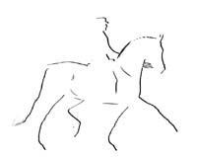

TEAM:
CAMPER:

